Python Programming Lab Task Sets

Set 5
- Q1. Generate Python code for the Fibonacci sequence with Cursor AI. Refine your prompts to handle only positive integers and record the changes and outcomes.
(Each question carries 5 marks)
Prompt :
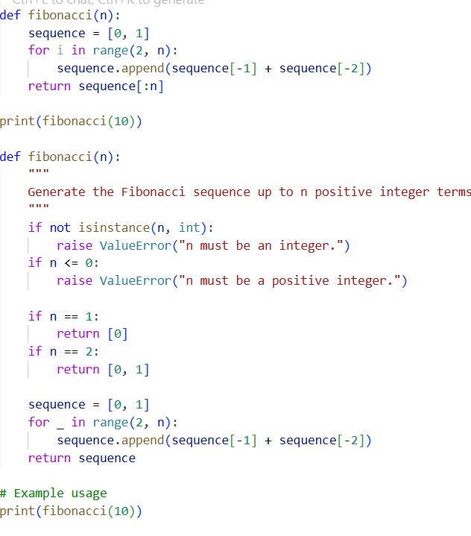
Write Python code that generates the Fibonacci sequence up to n terms

OUTPUT:
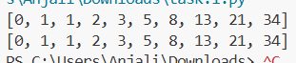

Refined prompt
Refactor the Fibonacci generator so that it only accepts positive integers.
If the input is zero, negative, or not an integer, raise a ValueError with a clear message.
Return a list containing the Fibonacci sequence up to n terms.
Provide clean, production-ready Python code.
Code:

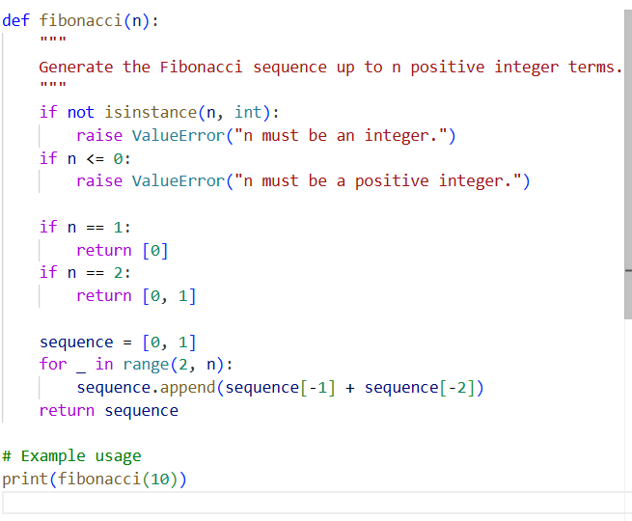

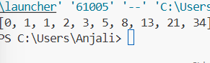
- Q2. Write a Python queue class (`enqueue`, `dequeue`, `peek`). Use an AI assistant and test the class with multiple scenarios. Describe how AI-generated code manages edge cases and how you improved it.:

PROMPT:

Write a Python program that defines a Queue class with enqueue, dequeue, and peek methods. Then test the class with several operations (adding, removing, peeking) and include cases where the queue is empty. After the code, explain how edge cases were handled and how you improved the AI-generated code.
CODE:
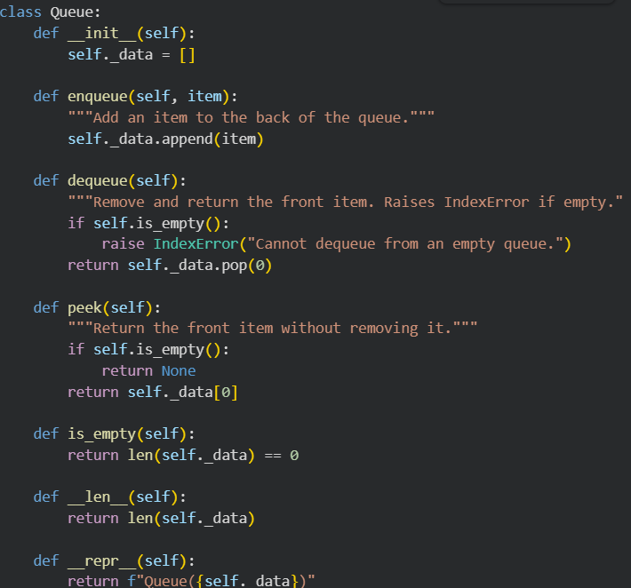
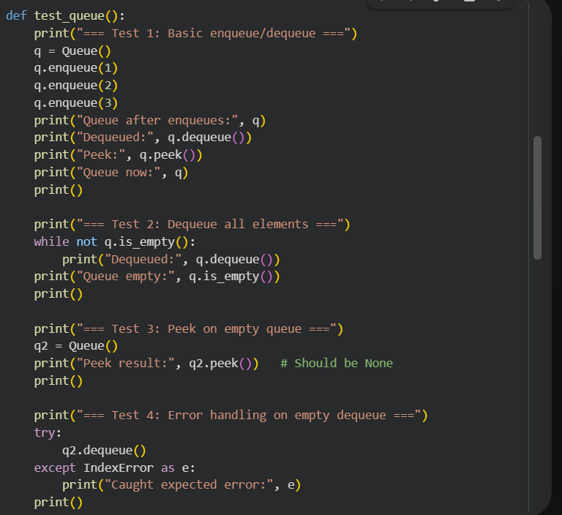
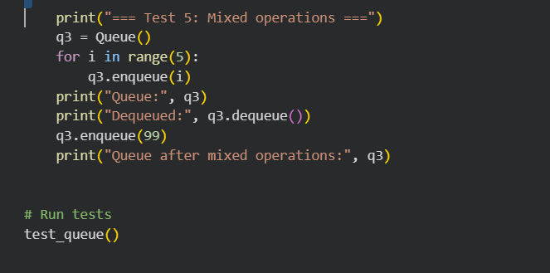
OUTPUT:
